Modeling Accessibility of Health Facilities in Haiti after Hurricane Matthew 2016
Isabel Miranda and Kelsey Meisenhelder
imiranda@clarku.edu
kmeisenhelder@clarku.edu
Advanced Vector GIS, Fall 2016
Abstract
On October 4th, 2016 Category four Hurricane Matthew hit eastern Haiti, causing catastrophic damage. As of October 10th, the United Nations estimated that 1.4 million people in Haiti are in need of humanitarian assistance, with over 1,000 people dead. The cities of Les Cayes, Port Salut and Jérémie sustained the most damage. This project examined the five most populated cities affected by the hurricane. Network analysis was used to determine the percentage of households that are accessible to health services, defined as within a 1-hour walk or 5km. This analysis considered building damage from the Copernicus Emergency Management Services (EMS) for each city, alongside Humanitarian OpenStreetMap data for roadways and health facilities. Results indicated decreased accessibility in Jérémie (1%) and Les Cayes (20%), and an average accessibility of 52% for households in our five study areas after the hurricane.

Problem Statement
Objectives
This study will consider 5 communities within the Hurricane Matthew swath that include Jérémie, Port Salut, Les Cayes, Dame Marie and Les Anglais (Figure 1). The objectives of this project are to (1) determine which local health centers are in zones of destruction, (2) use network analysis to create service areas of 1, 3 and 5km distances around health centers, and (3) compare percentage of households within service area polygons given different road access constraints from October 4th and October 27th. This analysis will be done using the tool network analyst with ArcGIS 10, this will allow us to use roadways as a network to connect settlements to health facilities to create service area polygons. We hypothesized that the destruction of health facilities and road blockages would decrease the accessibility of healthcare for the majority of people in these communities. In the aftermath of Hurricane Matthew, the vulnerability of certain communities is important for informing aid organizations where the greatest need is for medical aid. This study is a pilot study of network analysis as a means of determining greatest need for health services to best inform humanitarian relief efforts.
Literature Review
The arrival of hurricane Matthew on October 24th 2016 caused catastrophic damage within the western edge of Haiti (BBC). As of October 10th, the United Nations estimated that 1.4 million people in Haiti are in need of humanitarian assistance, with over 1,000 people dead (Rebecca 2016). The cities of Les Cayes, Port Salut and Jérémie were most affected by the hurricane, where trees, houses and cellphone towers were nearly all destroyed or badly damaged (Rebecca 2016). In the Sud Department consisting of Les Anglais, Les Cayes and Port Salut 28% of the health centers sustained severe damage and 8% are closed. The Haiti’s Ministry of Health is responding to the outbreak with the support of NGOs and other partners but there still need additional support to make damaged facilities operational (PACHO, 2016).
To further assess the aftermath of the hurricane, network analysis will be used to determine the distance community members must travel to access health care within the five most populated cities in western Haiti that fell within the hurricane path. Previous studies have utilized network analysis as a means of determining the accessibility of public goods including mass transit (Liu and Zhu 2004), and greenspace (Comber et al., 2008). Studies of accessibility of health care in developed locations have defined accessibility to health care as 30 minutes travelling in a personal vehicle in Michigan (Delamater et al., 2012), and 1 hour of walking, walking and cycling, or walking and public transportation in Rwanda (Munoz and Källestål, 2012). For our study we assume that alternative forms of transportation have been rendered unreliable after the hurricane, and define accessibility as within 1 hour of walking.
A study of health care accessibility in Niger considered 1-hour travel times as the absolute threshold distance for what considered a health facility to be “accessible,” (Blanford, 2012). This study investigated the seasonal difference in accessibility to health facilities, since the majority of roads in Niger are unpaved and fluctuations in precipitation affect ability to travel on certain roads when wet, and the travel times during slippery conditions (Blanford, 2012). The study found that 39% of people were accessible to a health facility during the dry season, while only 24% of people were accessible during the wet season (Blandford, 2012). The usage of a 1-hour travel time was adapted for our study. Future study could be supplemented by in situ knowledge of the paved status of roads in Haiti could investigate the pre- and post- hurricane road conditions to determine if travel times changed along with road conditions.
Tanser (2006) conducted a study to propose new locations for primary health care facilities that would provide access to rural communities in KwaZulu-Natal, South Africa. The study stresses the importance of addressing rural areas, where determining accessibility to health care is must be population specific, rather than denoted by a “reasonable assess” of 5km or one hour walk (Tanser, 2006). However, for the purpose of this study we will be focusing on high populated density cities to access populations with medical need after Hurricane Matthew. Further research could investigate health care accessibility in rural areas. Additionally, the study conducts a travel time model to estimate the average travel time to the nearest clinic using cost analysis with IDRISI Kilimanjaro (Tanser, 2006). The cost analysis takes into account the friction values or traveling speeds across different surfaces that future work could incorporate into modeling health care accessibility in Haiti (Tanser, 2006).

Data
For this study data on Haiti health facilities were acquired during the “Hurricane Matthew Coordinated Data Scramble” conducted by the Humanitarian Data Exchange (https://data.humdata.org/). Haiti Roads were collected from Humanitarian Open Street Map, road access constraints were collected from the World Food Programme, and the Haiti population dataset from World Pop Haiti. Additionally, data for the five cities of interest, Jérémie, Les Anglais, Port Salut, Les Cayes and Dame Marie were collected from the Copernicus EMS which included a grading scale of destruction of settlement (house) points and transportation lines. See Table 1 for a complete list of GIS data layers to be used.

Methods
See methodology and GIS workflow in Figure 2.
- Deciding areas of interest. We compared the World Pop Data of population density in Haiti with the Copernicus EMS areas of interest, and chose the five areas of interest that overlapped with areas of highest population density within the damaging wind extent of Hurricane Matthew (Figure 1).
- Determining the damage to local health facilities. We visually examined the degree of damage to neighboring health facilities of houses, and all health facilities with majority of neighboring houses marked as “completely destroyed” OR “highly damaged” were assumed to be non-operational or destroyed. These facilities were then removed from the health facility mapping layer, and excluded from network analysis.
- Creating a network dataset consisting of roadways, paths, and accounting for their constraints. We used ArcCatalog to create a network dataset derived from our OpenStreetMap data of major roadways. We used two Road Access Constraints datasets defined by the World Food Programme for Oct. 4, 2016 and for Oct. 27, 2016 as point restrictions for the network dataset.
- Creating health center service areas. We added our updated health facilities layer as facilities in the Network Analyst tool, and then generated service area polygons radiating away from the facility using 1km, 3km, 5km as the Default Breaks, keeping detailed polygons. This 5km threshold was derived from the 1-hour maximum walking distance set out in the literature (Munoz and Källestål 2012; Blanford 2012). We ran the Network Analyst tool twice; first using the Oct. 4, 2016 road access constraints data layer, and then again using the updated Oct. 27, 2016 road access constraints.
- Comparing health care accessibility across Oct. 4 and Oct. 27, 2016. We examined our service area polygons created using the two road access constraints layers, and discovered that all of the constraints were out of range (5km) of our health centers. Since the road constraints for both dates created identical service areas, we chose to only include our maps of Oct. 4 service area polygons for publication.
- Calculating the number of households within service areas. We used select by location to calculate the number of houses that were within 5km of a health center and have access to health care.

Results
- Dame Marie
The north east city of Dame Marie experienced relatively low damage, with 55% of houses having some degree of damage, and only 29% of houses completely destroyed (Figure 3, A). Of the two health centers in the city, both were deemed functioning in our analysis. Examination of service area polygons surrounding these two health centers (Figure 4, A) indicates that the majority of houses fall within 1-3km of a facility, with a total of 90% of all households within 5 km (Figure 4). Obstacles were located further than 5km from a health center and therefore did not affect results.
- Port Salut
The southern part of Port Salut experienced less damage than the center northern part of the city with 42% of houses having some degree of damage with 38% of house being completely destroyed (Figure 3, B). No health centers were contained with the city boundary of Port Salut, however three health centers that extended beyond the city boundaries were analyzed for accessibility to health centers. Obstacles were located further than 5km from a health center and therefore did not affect results. Examination of service area polygons surrounding these three health centers (Figure 4, B) indicates that the majority of houses fall within an area of 5km more away from a facility, with a total of 44% of all households falling within 5km of the service area polygons (Figure 5).
- Les Anglais
The southern city of Les Anglais was incredibly damaged by the full force of the hurricane, with 86% of houses having some degree of damage, and 73% of houses completely destroyed (Figure 3, C). There was only one health center in the city, and it was deemed functioning for our analysis. Obstacles were located further than 5km from a health center and therefore did not affect results. Examination of service area polygons surrounding this health centers (Figure 4, C) indicates that the vast majority of houses were farther than 5km away from a facility, with only 2% of all households within 5km (Figure 5). The shape of these polygons do not follow traditional radiating patterns around health facilities as a result of the coarse resolution of our streets data. This health center (Figure 4, C) does not intersect with a major street, thus affecting the creation of the service area.
- Jérémie
The north east city of Jérémie experienced moderate damage, with 74% of houses having some degree of damage, and 56% of houses completely destroyed (Figure 3, D). Of the seven health centers in the city, only five were deemed functioning in our analysis. Obstacles were located further than 5km from a health center and therefore did not affect results. Examination of service area polygons surrounding these five health centers (Figure 4, D) indicates that the majority of houses fall within 1-3km of a facility in the interior of the city, but that homes along the coast were at travel distances of 5km or greater. The total percentage of households that were within 5km of a health facility was 71%, a 1% decrease from pre-hurricane conditions (Figure 5).
- Les Cayes
The along the coast and center of Les Cayes there is high damage, with 87% of houses having some degree of damage with 71% of houses completely destroyed (Figure 3, E). There were 11 health centers that were removed from the coast and downtown of the city, leaving two remaining health centers. The two health centers in the city, both were deemed functioning in our analysis. Road obstacles are also included into the analysis, as noted in the coast of Les Cayes. Examination of service area polygons surrounding these two health centers (Figure 4, E) indicates that the majority of houses which are completely destroyed and highly damaged are 5km or more away of a facility, with a total of 53% of all households within the service area polygons, a 20% decrease from pre-hurricane conditions (Figure 5).
Conclusion
The average percentage of households that had access to a health center was 52% across our study areas after Hurricane Matthew. The greatest accessibility (90%) was in Dame Marie, which was the least damaged city and had two functioning health centers. Les Anglais had the lowest percentage of households within 5km of a health center (2%), and was also the most damaged city and had only one functioning health center. Since higher degrees of damage resulted in our removal of health centers from the analysis, there was less accessibility in those regions of extreme damage (Figure 4). Hurricane damage to health centers in Jeremie (2 damaged) and Les Cayes (11 damaged) decreased accessibility from pre-Hurricane conditions by 1% and 20%, respectively (Figure 4). However, for the cities with no damaged health centers, Dame Marie, Les Anglais, and Port Salut, these service area polygons also represent the pre-Hurricane accessibility to health services. It should be noted that the obstacles recorded did not intersect with any of our service area polygons, and thus did not impact our analysis or demonstrate difference in accessibility from Oct. 4 to Oct. 27, 2016.
The implications for these results are concerning, as they indicate an incredible gap between human need and infrastructure. We recommend humanitarian organizations focus their efforts on the cities with highest degrees of damage and lowest accessibility to health care, Les Anglais, Les Cayes, and Port Salut. By targeting these communities with greatest need, organizations can best organize efforts to mitigate the aftermath of this natural disaster. As of November 3rd the Pan American Health Organization (PAHO) supports the preparation in a Post Disaster Needs Assessment and is working to implement it with Haiti’s Ministry of Planning and External Cooperation. Organizations have identified 5 priority areas of action such as restoring health care delivery capacity and access to health services in the most affected areas (PACHO, 2016). Therefore, humanitarian organizations are addressing the importance to restore health facilities and accessibility within most affected areas of Haiti.
Further study should consider the usage of finer resolution streets, paths, and road networks, as our country wide streets layer restricted our service area polygons to major roads. The addition of minor paths and streets would provide greater accuracy of service area polygons, and would resolve our error of having polygons largely following streets rather than health centers. Additionally, acquiring updated health facility data from 2010 onwards would allow the creation of service areas to be more representative of current health facility distribution. We recommend collaborating with local communities to conduct participatory GIS and post-disaster assessments to provide up to date data on road obstacles, extent of damage, and areas of greatest need. The collection of such data would require adequate technology, training, and communication infrastructure.

Literature Cited
BBC. “Hurricane Matthew: Category Four storm pounds Haiti.” BBC News. 05 Oct. 2016, accessed 18 Oct. 2016. http://www.bbc.com/news/world-latin-america-37549219
Blanford, J. I., Kumar, S., Luo, W., & MacEachren, A. M. 2012. It’s a long, long walk: accessibility to hospitals, maternity and integrated health centers in Niger. International Journal of Health Geographics, 11, 24. http://doi.org/10.1186/1476-072X-11-24
Comber, Alexis, Chris Brunsdon, and Edmund Green. 2008. "Using a GIS-based network analysis to determine urban greenspace accessibility for different ethnic and religious groups." Landscape and Urban Planning 86.1 2008: 103-114.
Delamater, Paul L., Messina, Joseph P., Shortridge, Ashton M., Grady, Sue C. 2012. “Measuring geographic access to health care: raster and network-based methods.” International Journal of Health Geographics, 2012, 11:15. Accessed online 18 Oct. 2016.
Liu, Suxia and Zhu, Xuan. “Accessibility Analyst: An Integrated GIS Tool for Accessibility Analysis in Urban Transportation Planning.” Environ Plann B Plann Des February 2004 vol. 31 no. 1 105-124. Accessed online 18 Oct. 2016. http://epb.sagepub.com/content/31/1/105.short
Munoz, Huerta and Källestål, Carina. Geographical accessibility and spatial coverage modeling of the primary health care network in the Western Province of Rwanda. 2012. International Journal of Health Geographics. 201211:40 DOI: 10.1186/1476-072X-11-40 Retrieved from: https://ij-healthgeographics.biomedcentral.com/articles/10.1186/1476-072X-11-40
Noor, A. M., Amin, A. A., Gething, P. W., Atkinson, P. M., Hay, S. I., & Snow, R. W. 2006. Modelling distances travelled to government health services in Kenya. Tropical Medicine & International Health : TM & IH, 11(2), 188–196. Retrieved from: http://doi.org/10.1111/j.1365-3156.2005.01555.x
PAHO. (2016, November 3). Haiti needs support to restore, rebuild health services after Hurricane Matthew. Retrieved December 13, 2016, from http://www.paho.org/hq/index.php?option=com_content&view=article&id=12707:haiti-needs-support-restore-rebuild-health-services-after-hurricane-matthew&Itemid=1926&lang=en
Rebecca, K. K. "Photos and Detailed Maps Reveal Hurricane Matthew’s Brutal Aftermath in Haiti." The New York Times. The New York Times, 09 Oct. 2016. Web. 18 Oct. 2016.
Tanser, F. 2006. Methodology for optimising location of new primary health care facilities in rural communities: a case study in KwaZulu-Natal, South Africa. Journal of Epidemiology and Community health, 60(10), 846-850.

Figures
Table 1: GIS data layers to be used in the analysis
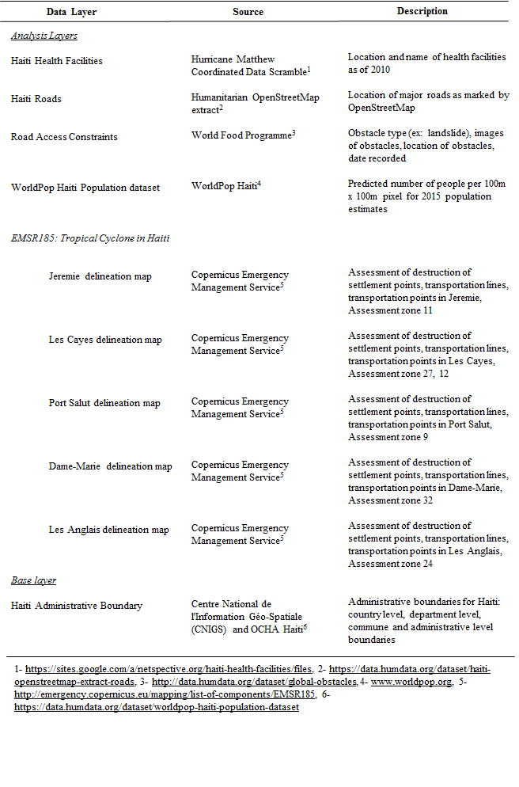

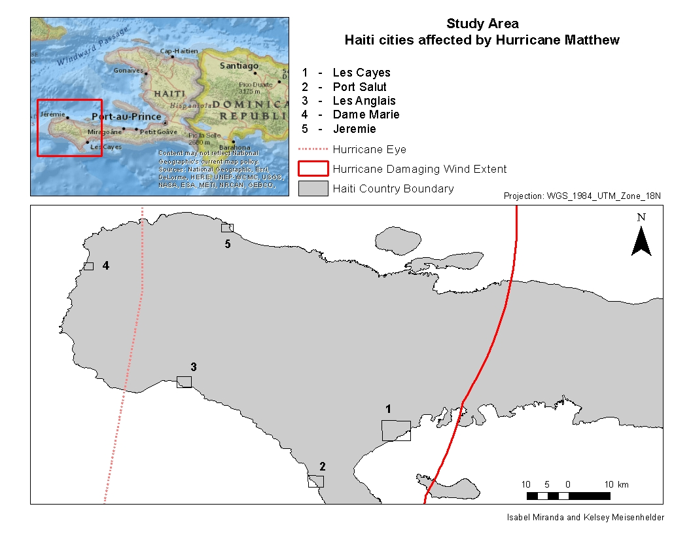
Figure 1. Study Area including 5 cities of interest for Network Analysis.

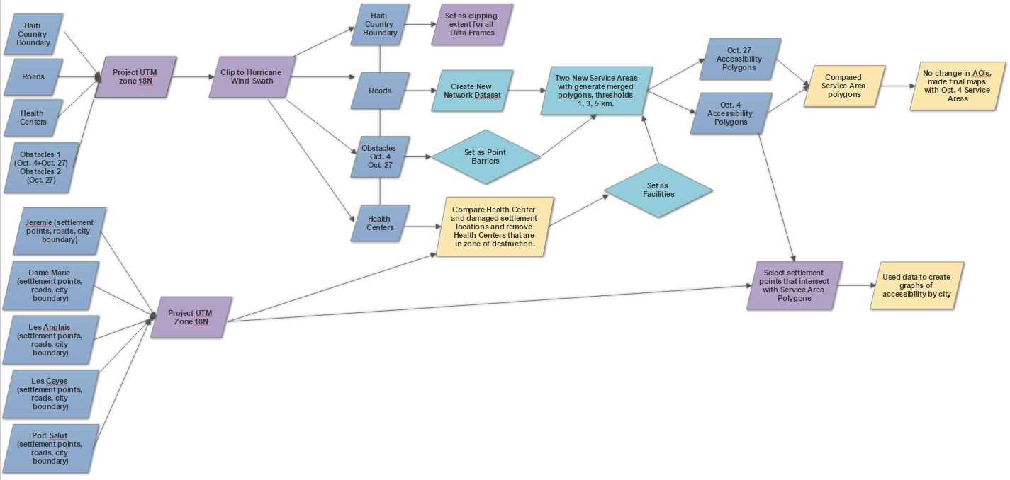
Figure 2. Methods flow chart: Our GIS workflow.
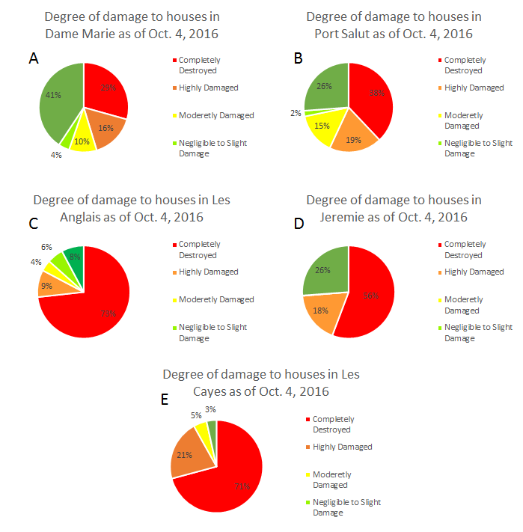Figure 3. The percentage of houses in each city according to degree of damage, as marked on the scale of “Not Affected” to “Completely Destroyed” by the Copernicus Emergency Management Service Oct. 4, 2016.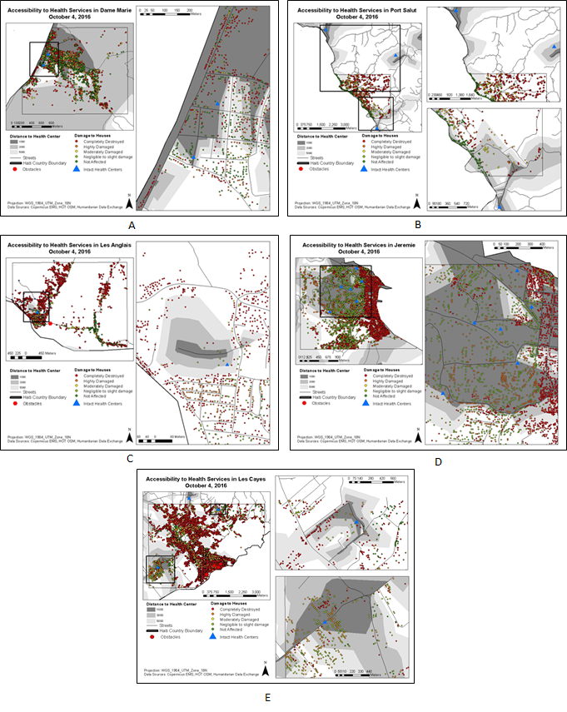Figure 4. Service area polygons of 1, 3 and 5km for Dame Marie, Port Salut, Les Anglais, Jeremie, Les Cayes.

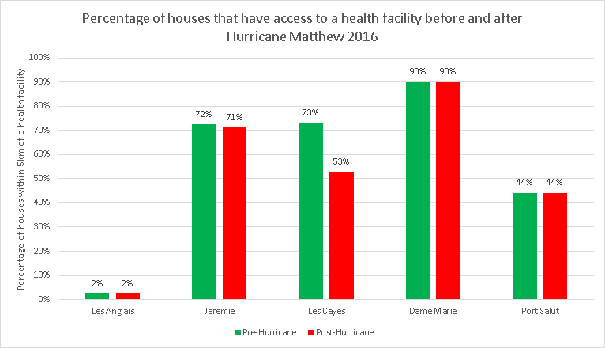
Figure 5. The total percentage of houses in each of our study areas that were within a service area polygon (5km range) of a health facility before and after Hurricane Matthew’s landfall in Haiti, October 4, 2016.

